Flight 1A

1. Login Module

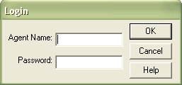

Fig 1.1 Login Module

- Agent Name: Specifies the name of the agent and it must be at least 4 characters long.
- Password: Accepts only the word “MERCURY”.
- OK Button: Logs in to the next module “Flight Reservation”.
- Cancel Button: Exists from the Login Module.
- Help Button: Displays the message box “The Password is MERCURY”.

2. Flight Reservation Module:

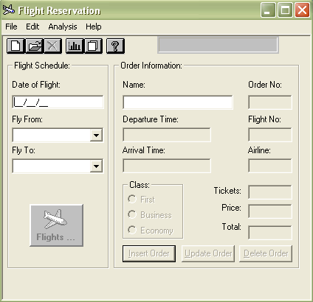
Fig 1.2 Flight Reservation Module

- Date of Flight: The format for date is mm/dd/yy.
- Fly from: The list box displays the places from where the flight gets departed.
- Fly To: The list box displays the places to where the flight arrives.
- Flight Icon: Shows the Flight Table that displays the flight information regarding the places that we select.
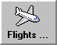
Fig 1.3 Flight Icon
- Flight Table: Views the information like Flight No, From, Departure time, To, Arrival time, Airline, Price

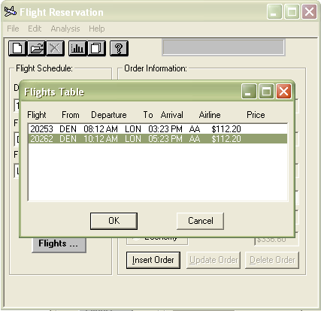
Fig 1.4 Flight Table

- Name: This is the name of the person who doing reservation and the name should not exceed 20 characters.
- Departure time: Retrieves the value from flight table dialog box.
- Arrival time: Retrieves the value from flight table dialog box
- Flight No: Retrieves the value from flight table dialog box.
- Airline: Retrieves the value from flight table dialog box.
- Order no: The order no is a sequence of numbers generated automatically after insertion operation.
- Ticket: Displays the no of tickets to be reserved.
      - Default value is 1
      - Maximum of 10 tickets can be reserved at a time.
- Class: It includes the options such as
  - First - Triple the cost of class “Economy”
  - Business - Double the cost of class “Economy”
  - Economy - Cost of ticket
- Progress Bar: Shows the process of insertion and updation of flight reservation.
- Price: Displays the cost associated with class and Airline.
- Total: Displays the total cost (associated with price and no of tickets) for the reservation.

- Insert Order
After entering all the details, the record is inserted by clicking insert order button.

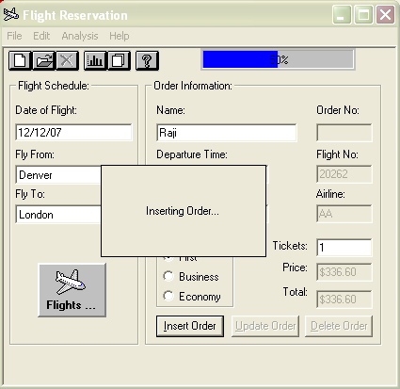
Fig 1.5 Insert Order dialog box

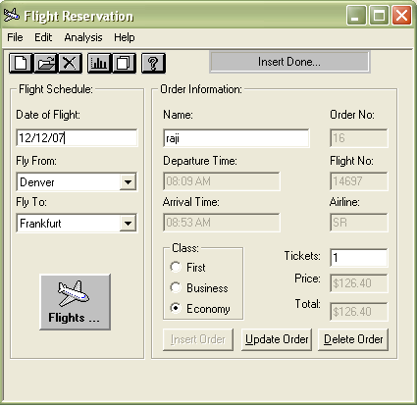
Fig 1.6 Insert Order dialog box

- Update Order
Updates the details of the Flight Reservation such Fly from, Fly to etc.
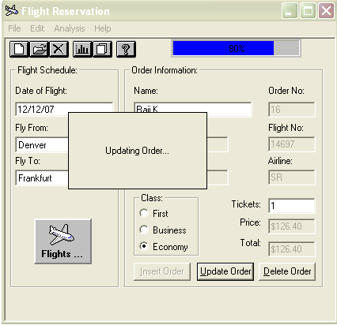
Fig 1.7 Update Order dialog box

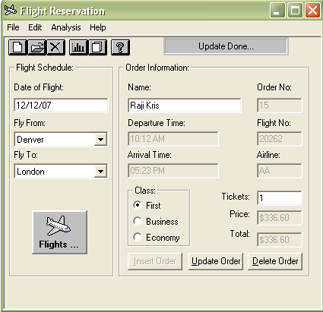
Fig 1.8 Update Order dialog box (After Updation)

- Delete Order
Deletes the order added to the database.

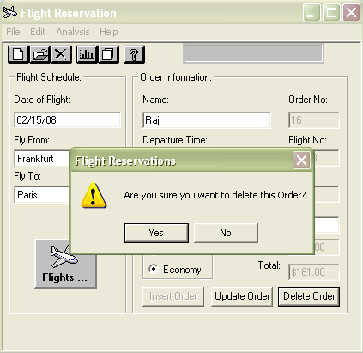
Fig 1.9 Delete Order dialog box

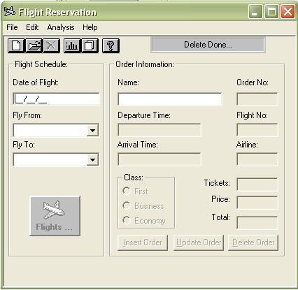
Fig 1.10 Delete Order dialog box (After deletion)

Menus on Flight Reservation Module:
- File
  - File -> New Order
A new order can be inserted by selecting file->new option

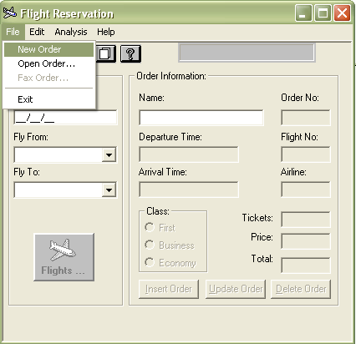
Fig 1.11 File (New Order) dialog box

- File -> Open Order
An already existing record could be opened by selecting file->Open option.

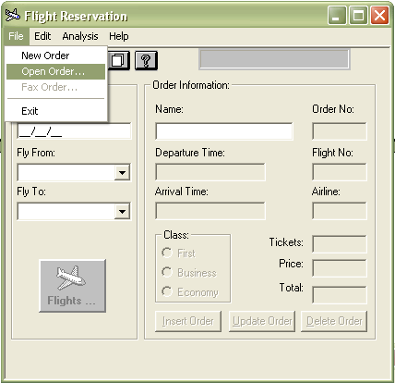
Fig 1.12 File (Open Order) dialog box

An open Order dialog box appears as shown below.

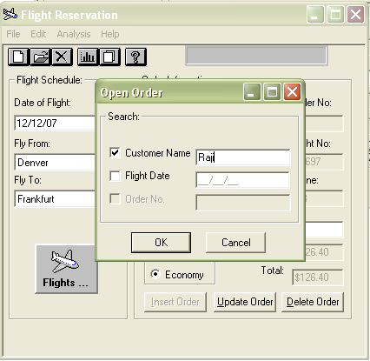
Fig 1.13 Open Order dialog box

The record could be opened by specifying any one of the following fields:
- Customer Name
- Flight Date
- Order No

- File -> Fax Order
When you click the Fax option from File menu, fax order dialog box appears so that a fax can be sent to any one of the required person.

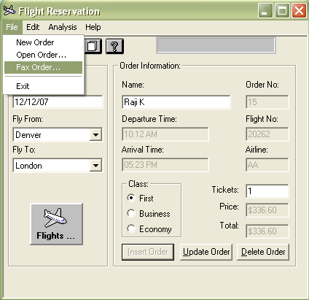
Fig 1.14 File (Fax Order) dialog box

Before sending the Fax, type the required Fax number in the Fax text box and put the signature of the agent in the Agent Signature Text box.
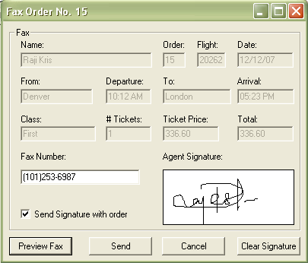
Fig 1.15 Fax Order dialog box

In Fax Order dialog box, the four command buttons are as follows:
- Preview Fax: The Fax Preview is shown as below
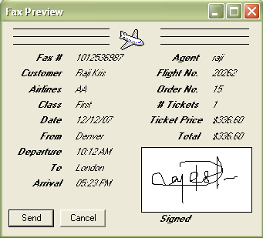
Fig 1.16 Preview Fax
- Send: The fax will be sent to the concerned person

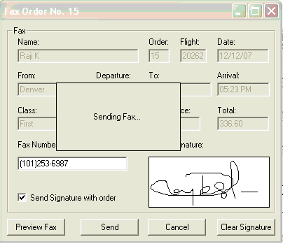
Fig 1.17 Sending Fax

- Cancel: The fax will be cancelled
- Clear Signature: This will clear the signature box

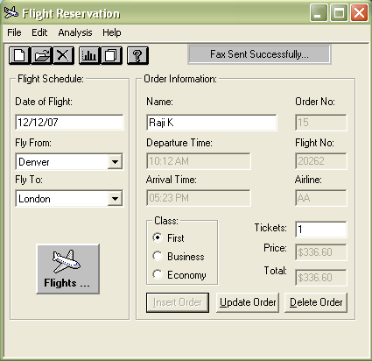
Fig 1.18 Progress bar shows Fax Sending message

- File->Exit
Exits from the Application
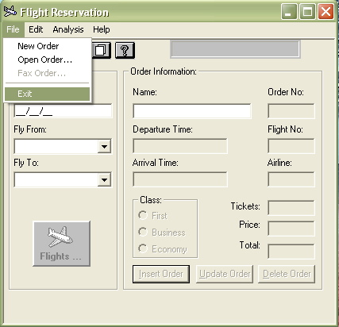
Fig 1.19 Exit option

- Edit
- Edit -> Copy, Cut, Paste: This will do the corresponding cut, copy and paste operations.

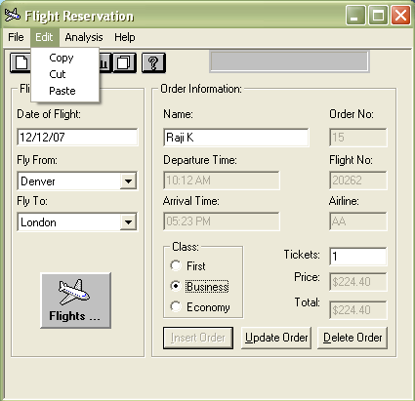
Fig 1.20 Edit dialog box

- Analysis
- Analysis -> Reports
It generates the report of all the records that has been added to the database.
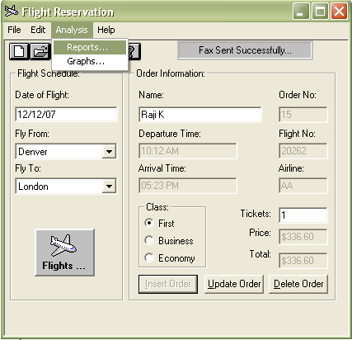
Fig 1.21 Analysis (Reports) dialog box
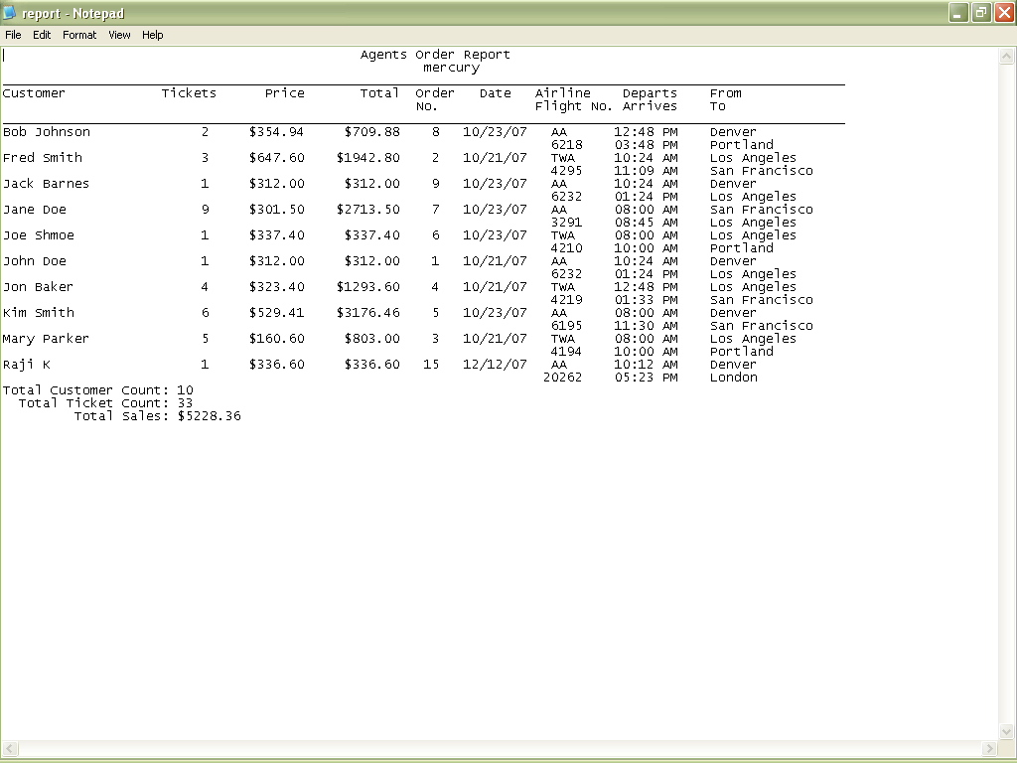
Fig 1.22 Reports

- Analysis -> Graphs
A graph shows the pictorial representation of the total tickets sold
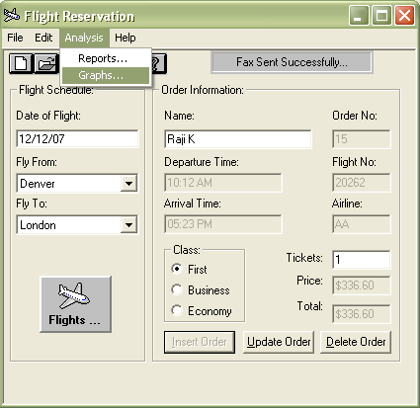
Fig 1.23 Analysis (Graphs) dialog box

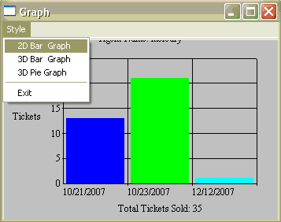
Fig 1.24 2D Bar Graph

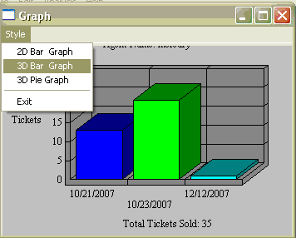
Fig 1.25 3D Bar Graph

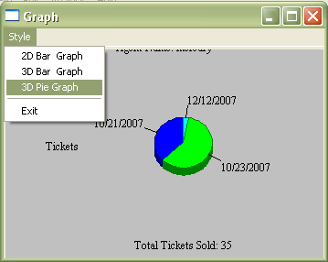
Fig 1.26 3D Pie Graph

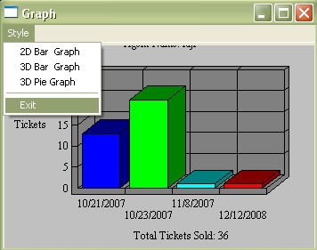
Fig 1.27 Graph Exit Option

- Help
  - Help -> Contents

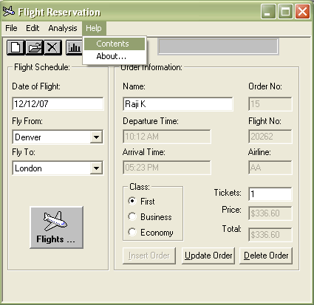
Fig 1.28 Help (Contents) dialog box
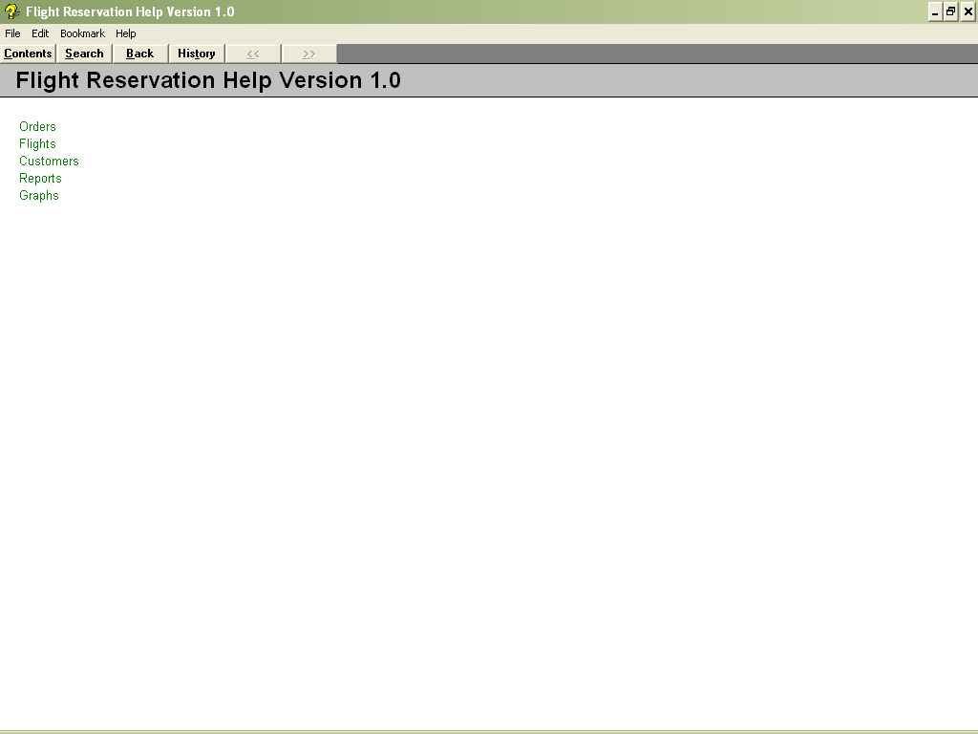
Fig 1.29 Help dialog box

- Help->About
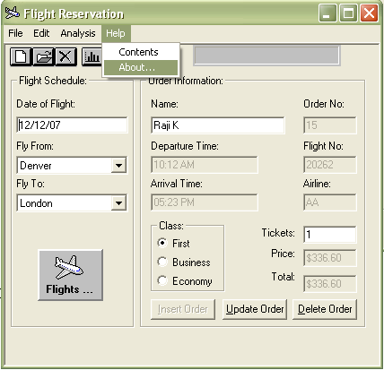

Fig 1.30 Help (About) dialog box

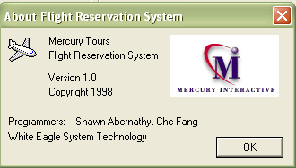

Fig 1.31 About dialog box
Tool bar on Flight Reservation Module:

New |  | Creates a New Order
Open |  | Opens an existing record
Delete |  | Delete an Order
Graph |  | Shows the pictorial representation
Report |  | Displays all the records from the database
Help |  | Provides the help facility

